King Mongkut's University of Technology North Bangkok (KMUTNB)
Bangkok, Thailand
KMUTNB Ground Station

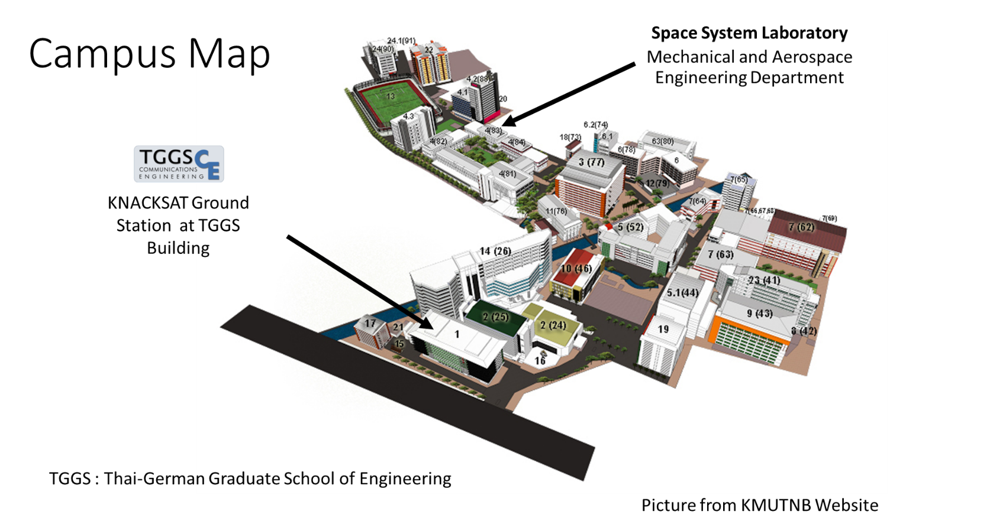

Prospective Ground Station that plan to install in 2016.
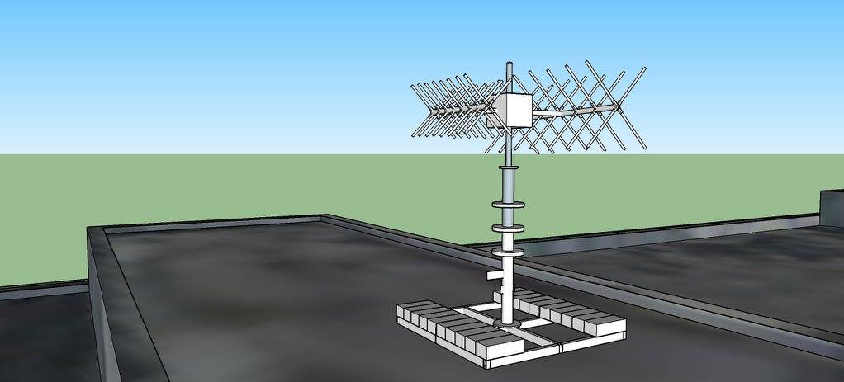
Drawing by Prof.Suramate Chalermwisutkul
Ground Station information
- Transceiver ICOM IC-9100
- Antenna: Cross Yagi-Uda
- Antenna Polarization: Circular (RCHP,LCHP)
- Rotator: Yaesu G-5500
- Station Callsign: HS0AK
- Altitude: 55 m above ground
- Latitude: 13.819091, Longitude 100.513775

KMUTNB Team member
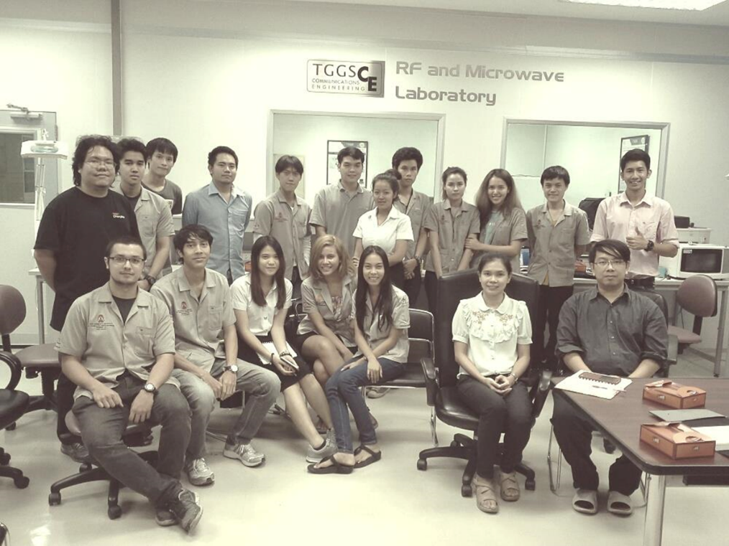
Communication Sub –System Team member
Staff member
Asst. Prof. Dr.-Ing. Suramate Chalermwisutkul
PhD student (Sub leader)
Mr. Vasan Jantarachote
Master Student
Ms. Syifa Hersista
Mr. Bhaskar Shivanna
Mr. Nonthapat Teerasuttakorn
Mr. Chodok Daraphan
Mr. Jirasin Tanglukchai
Ms. Thipamas Phakaew
Roof top of TGGS Building

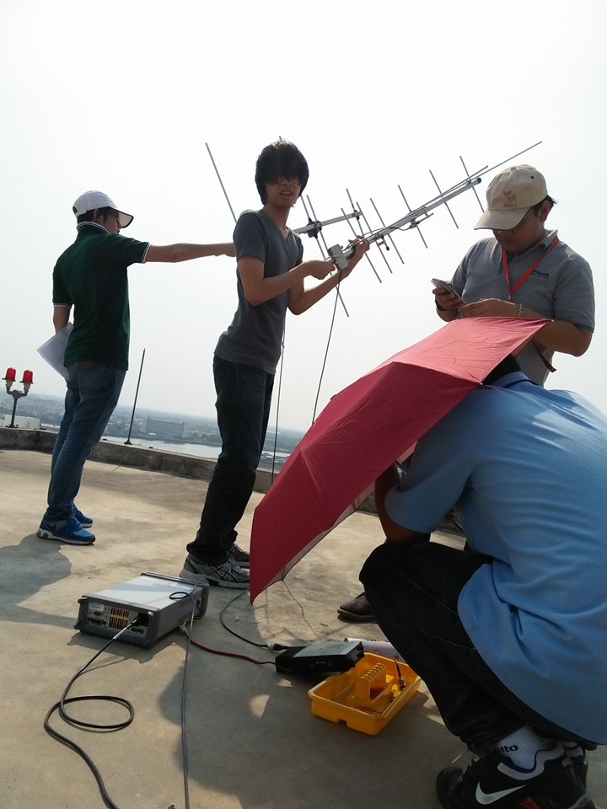
Activities
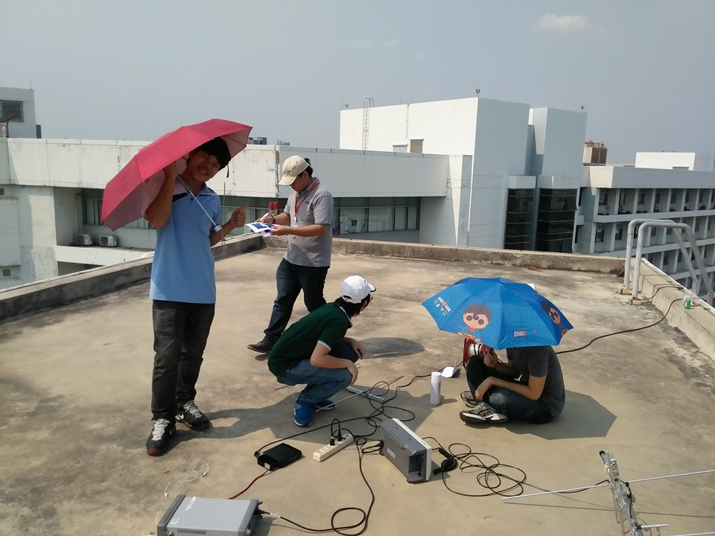

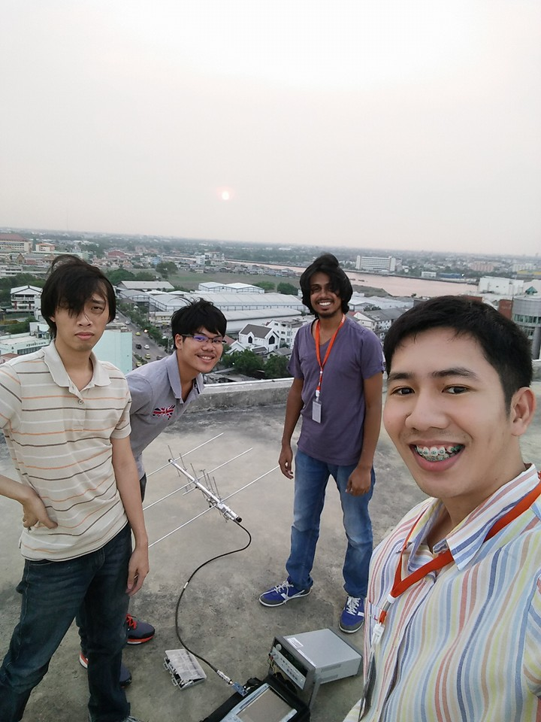
Team member survey the new location for ground station and use handheld antenna to receive the satellite signal.

